Scenario 8: Need to provide AWS access to a company employee using IAM identity center. Without creating an account for him in IAM.

Example: user – Sachin is part of our organization (learn.com), his designation is windows administrator, he needs an access to login to ec2 and perform below as a part of BAU.
He needs to have readyonlyaccess ( he should be able to view everything but edit only the below points)
Start instance
Stop instance
Reboot instance
Create snapshot
Delete snapshot.
He must be added to windows Admin OU.
We will grant these permissions without creating an IAM user, by using AWS IAM Identity Center (formerly AWS SSO).

Why IAM Identity Center?
IAM Identity Center allows:
- Centralized workforce access
- Integration with Active Directory
- No IAM user creation required
- Permission sets instead of IAM policies
- MFA enforced by default
This is the recommended method for enterprise access.

Step 1: lets create an OU named – Windows Admin in AWS organization.
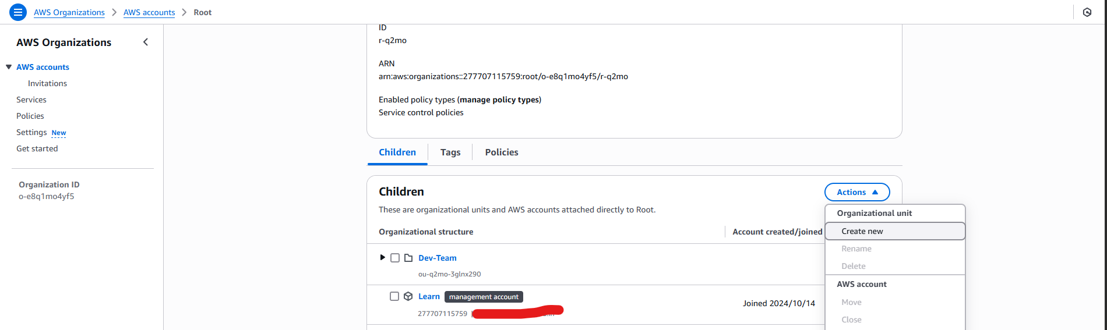

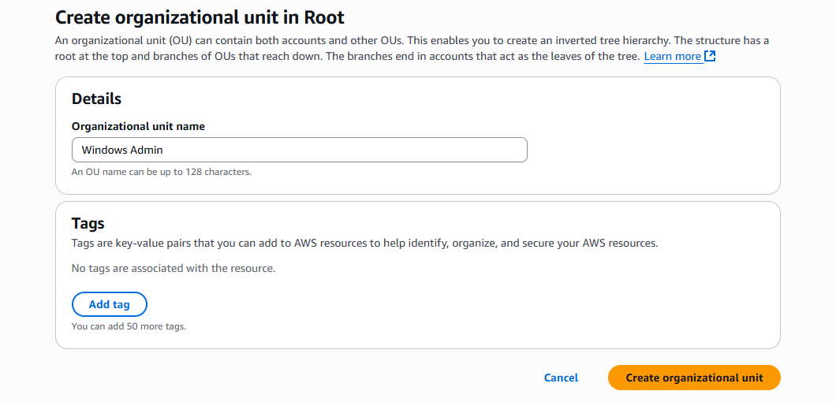

Step 2: Go to identity Center.
AWS Console → IAM Identity Center
We will configure identity-based access from here

Step 3: Create a Group > Windows Admin
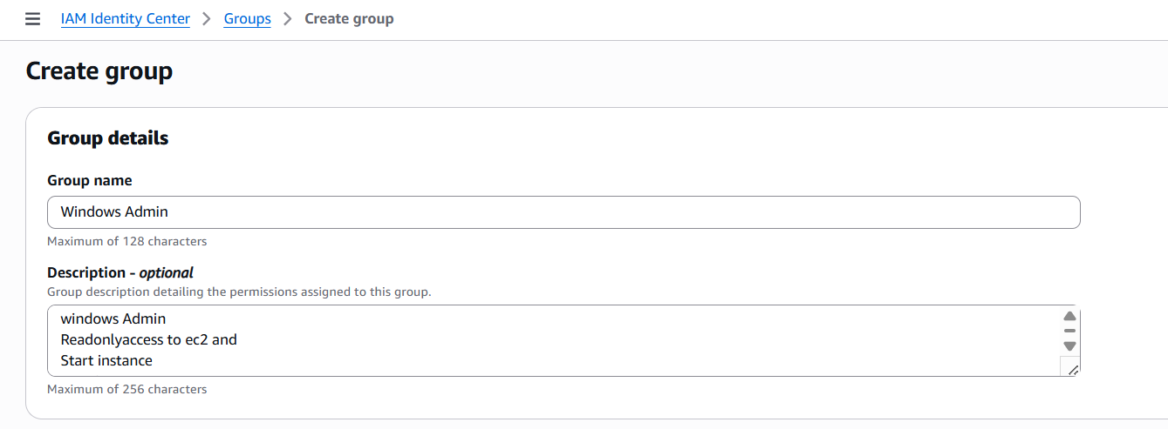

Step 4: create a user account under users and name it as Sachin.

you can choose either:
Option 1 — Recommended
Use External Identity Provider (Active Directory Sync)
Sachin will automatically sync from AD.
Option 2 — For Testing Only (Your Example)
Create a user manually and generate a one-time password.
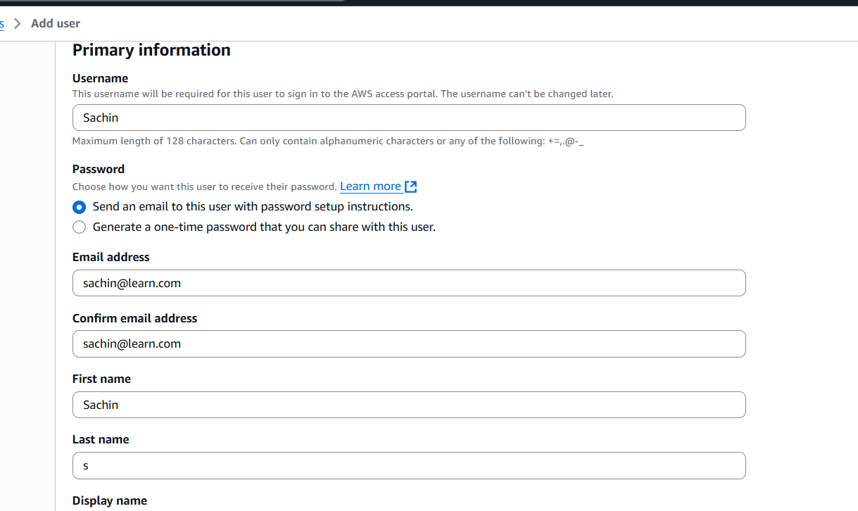
But for this example, I choose – generate one-time password that you can share with this user.
But The above (send an email to this user with password setup instruction)is the right recommended choice but am doing for an test purpose so I go for 2nd option.
And fill the gaps with the details of the user from AD.

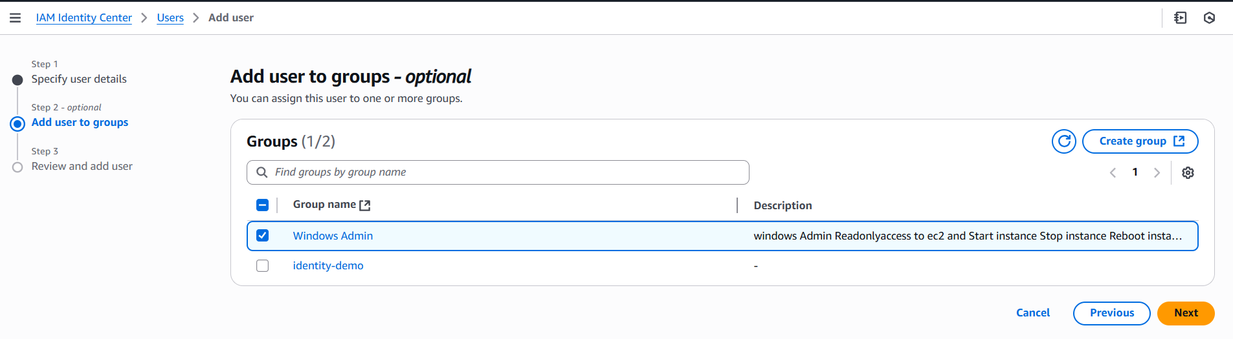

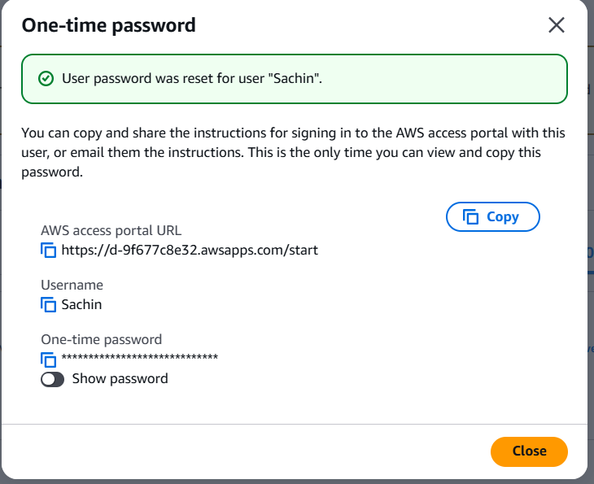

Still, we didn’t add any permissions for the user. If he try to access that portal URL it will be blank.
Once he try to access, we will be asked for username and password followed by to register to MFA.
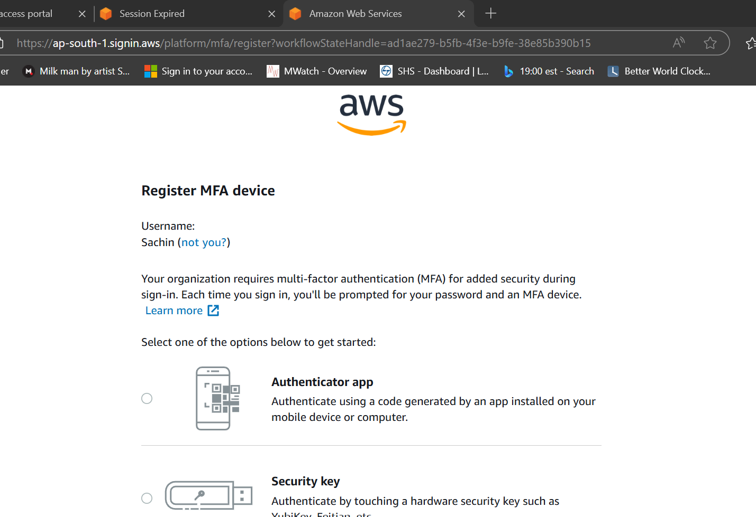
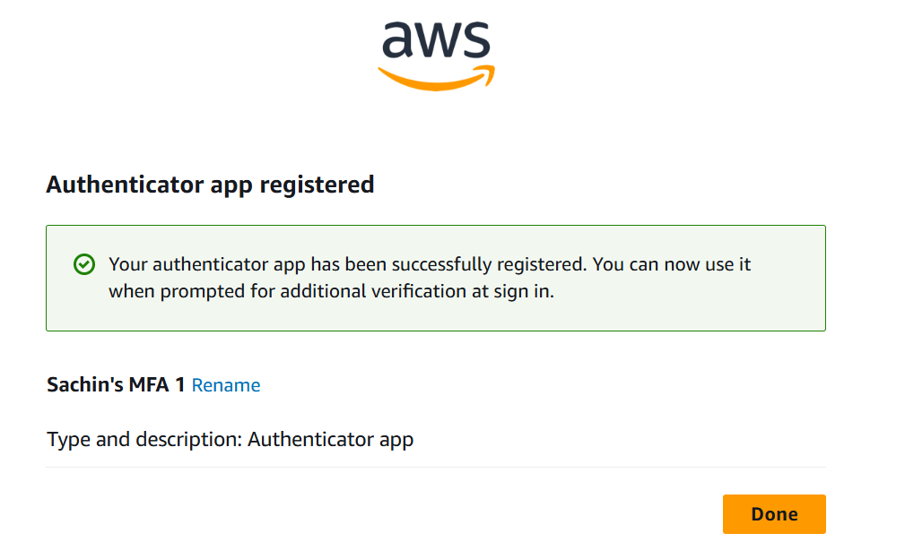
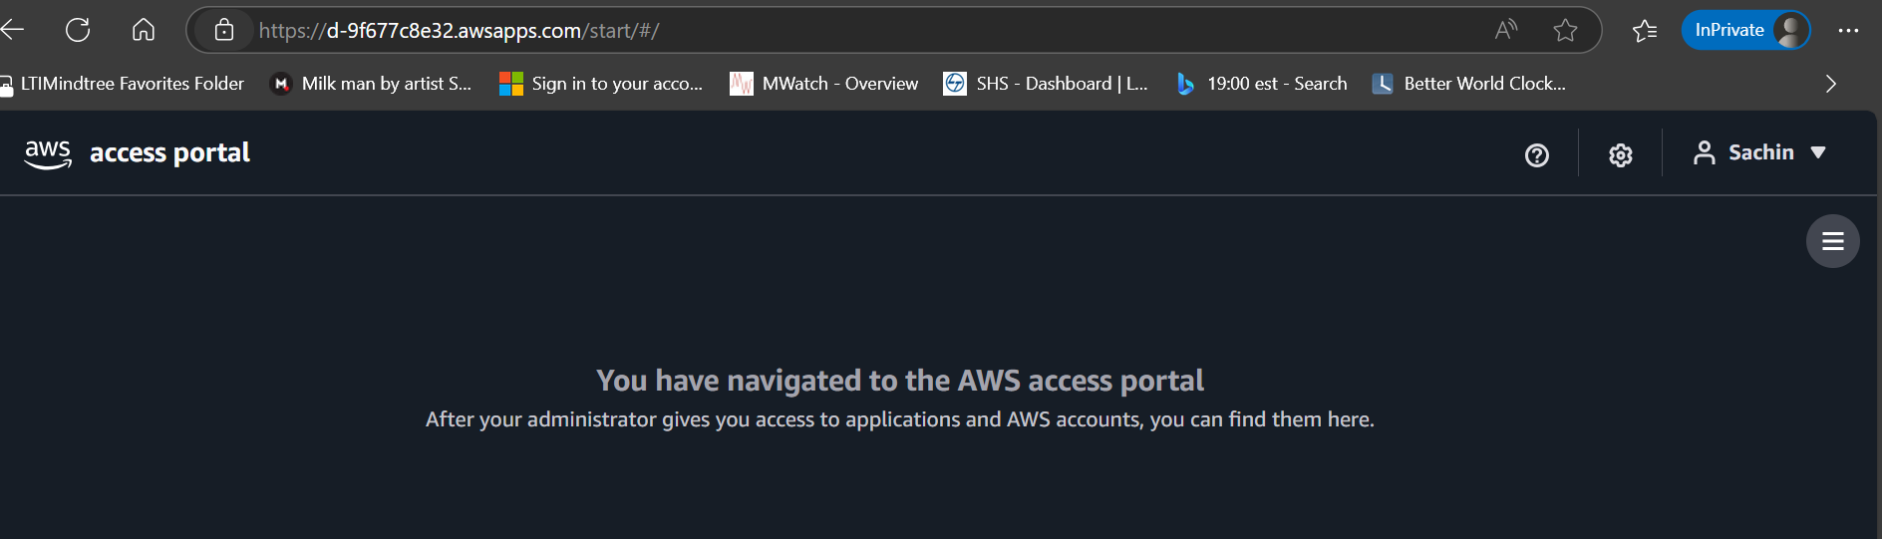
We could see that Sachin doesn’t have any access.

Step 5: Let’s provide him an access
Step 6: under multi-account permissions > create a permission set
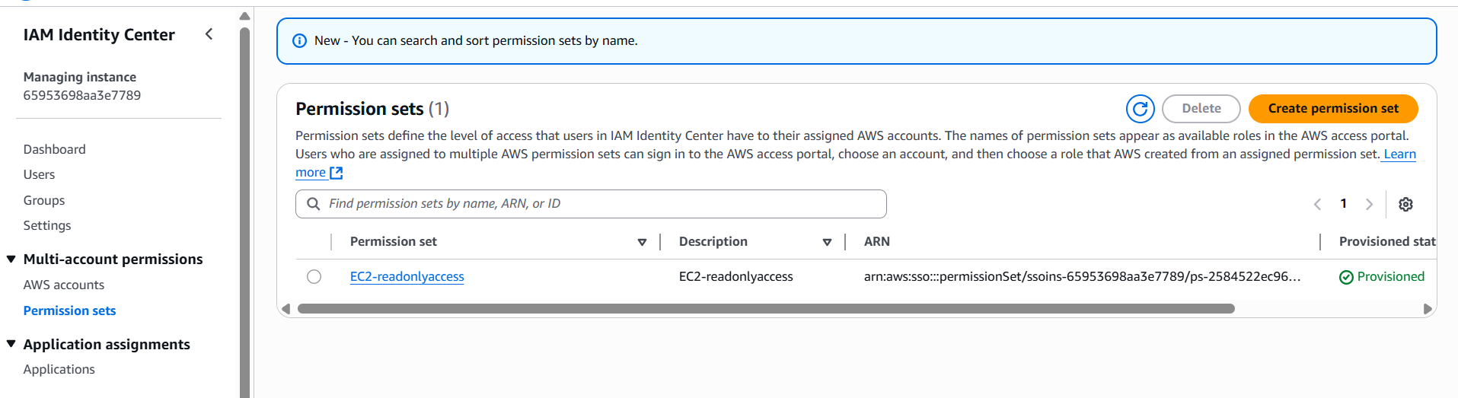
Step 7: create an custom policy allowing the windows Admin users to perform below
Note in resource add “*”
{
"Version": "2012-10-17",
"Statement": [
{
"Sid": "Statement1",
"Effect": "Allow",
"Action": [
"ec2:StartInstances",
"ec2:StopInstances",
"ec2:CreateSnapshot",
"ec2:CreateSnapshots"
],
"Resource": [
"*"
]
}
]
}
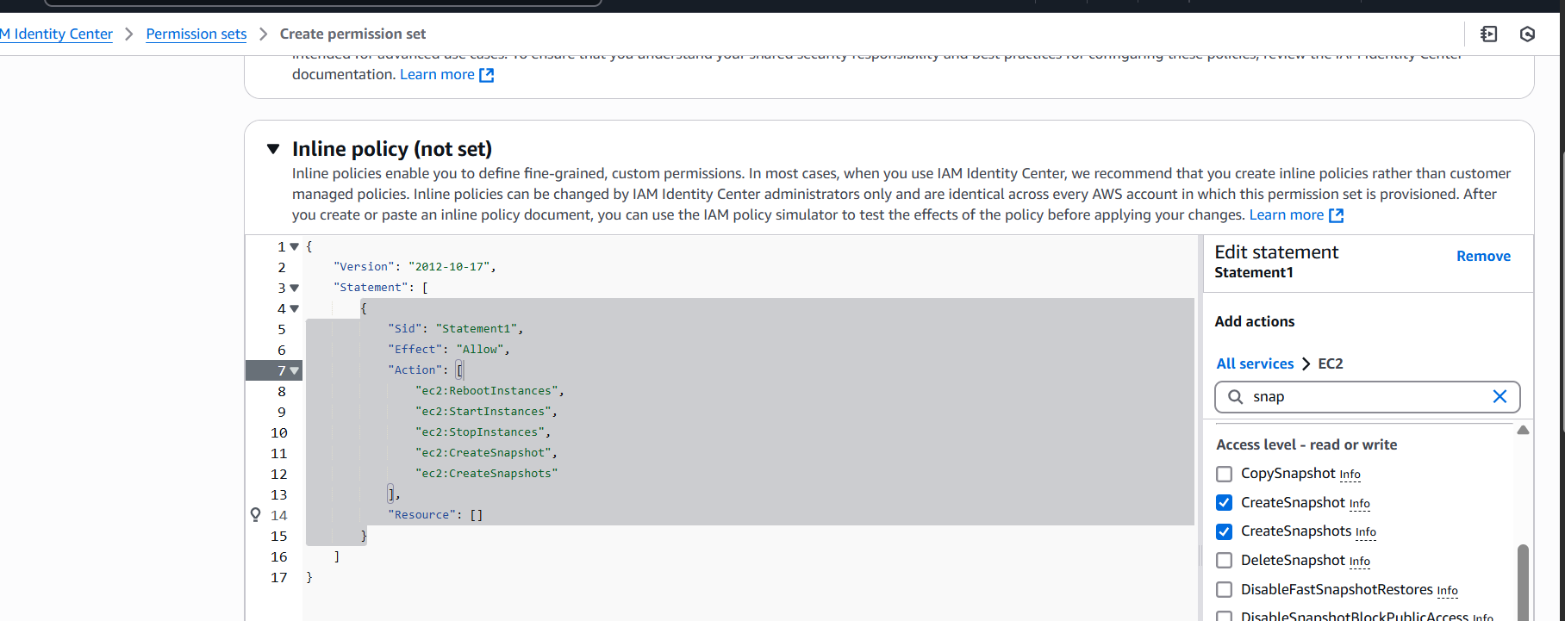
Step 8: session duration – 1hr
Means after 1hr , user needs to relogin.
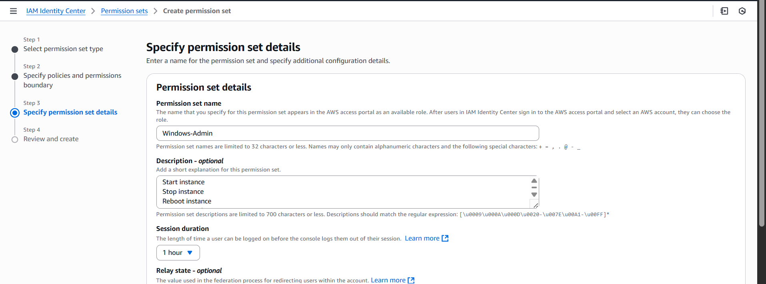
Step 9: under review and create step
Under AWS managed policies – add EC2Readonlyaccess policy also.
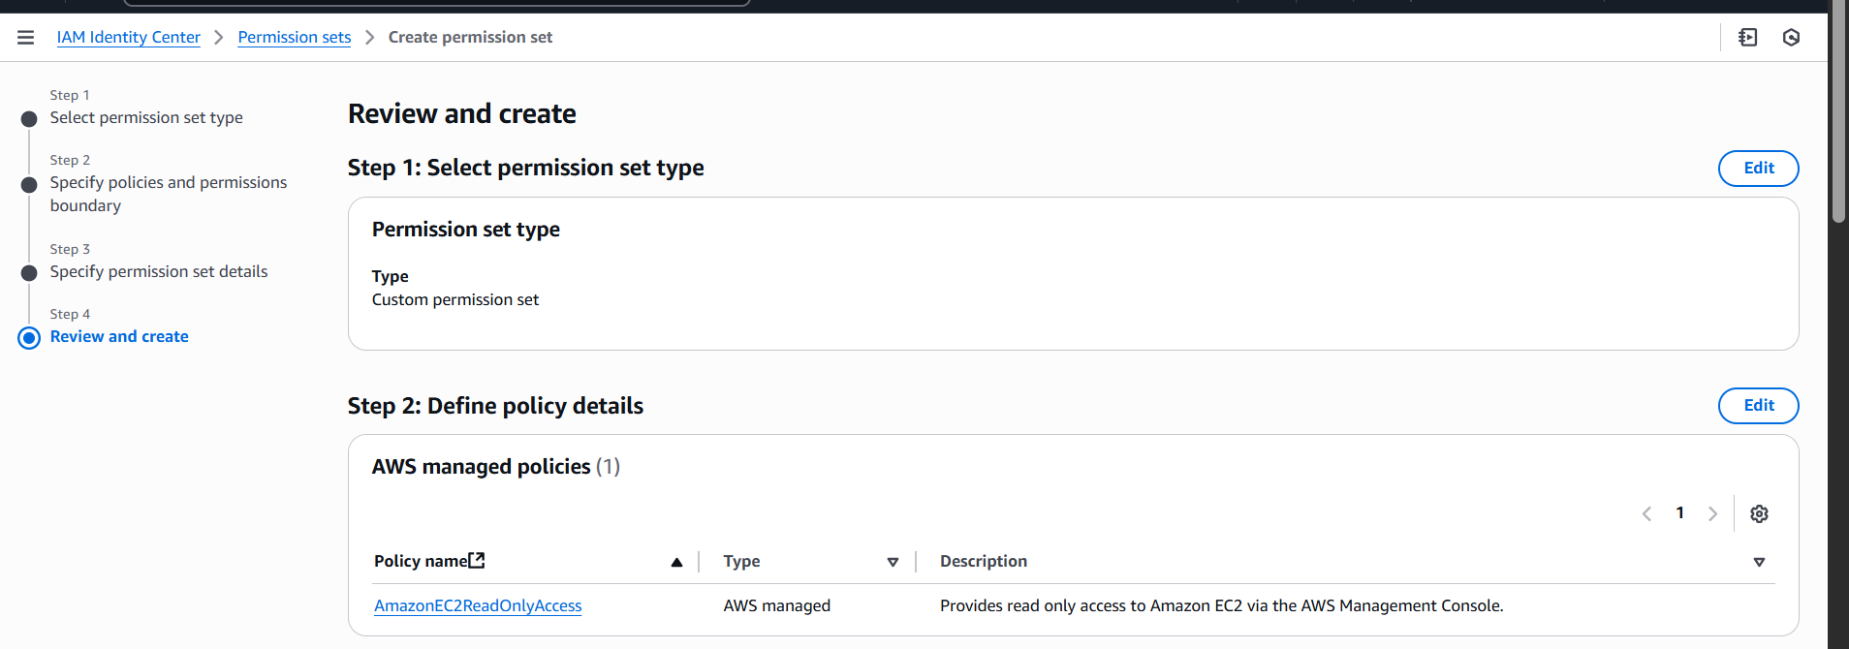
This ensures Sachin can view everything in EC2 but only perform the allowed actions above.

Step 9: Assign the permission set to the AWS account
Multi account-permission > assign users or groups
Select the aws account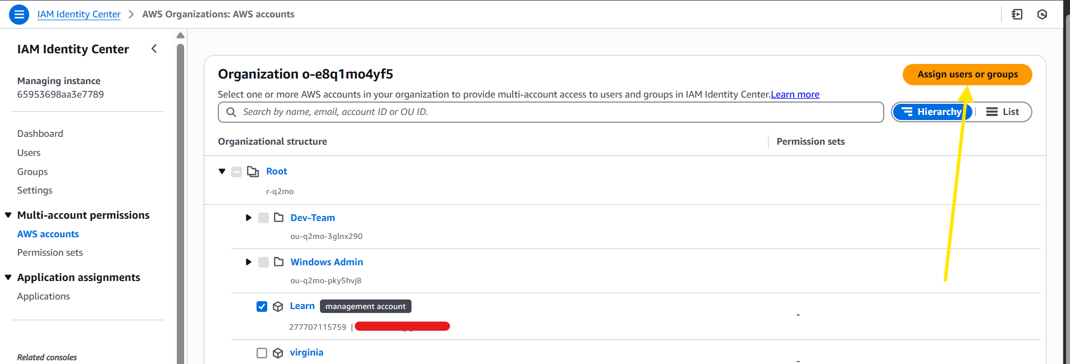
Step 10: select the group and click on next
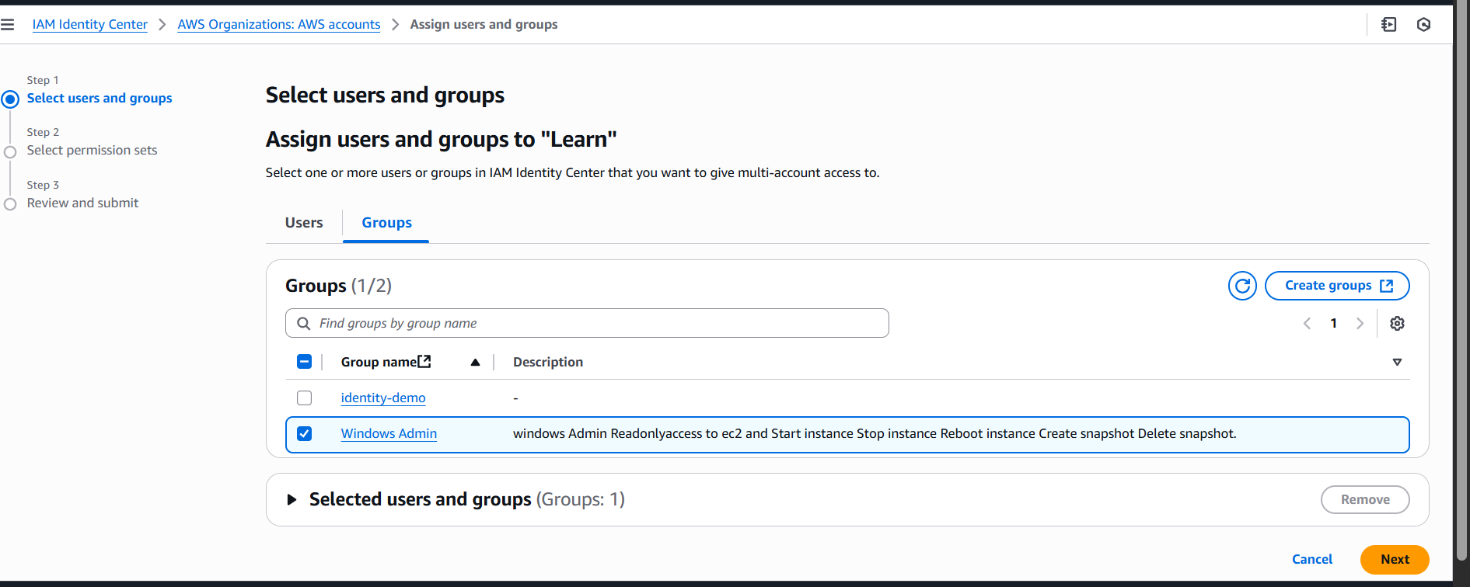

Step 11: select the permission set
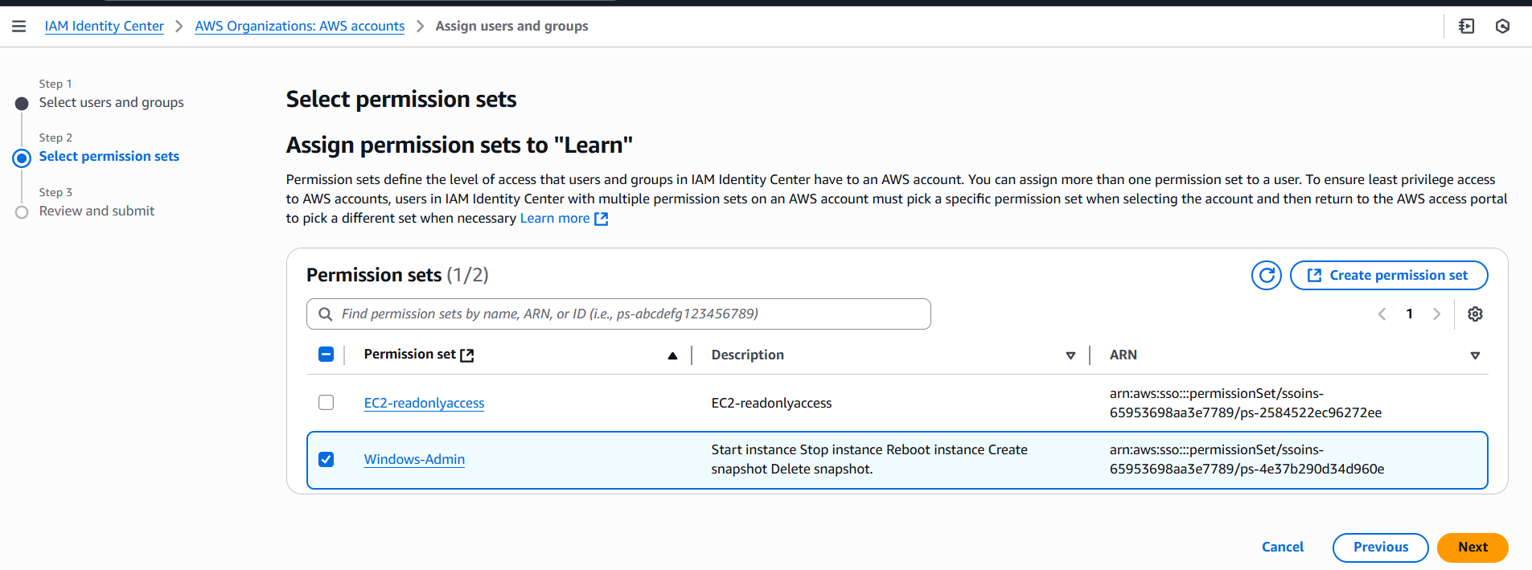
Step 12: review and create.
Step 13: Ask for user Sachin to validate
We could see the Sachin is able to view the dashboard
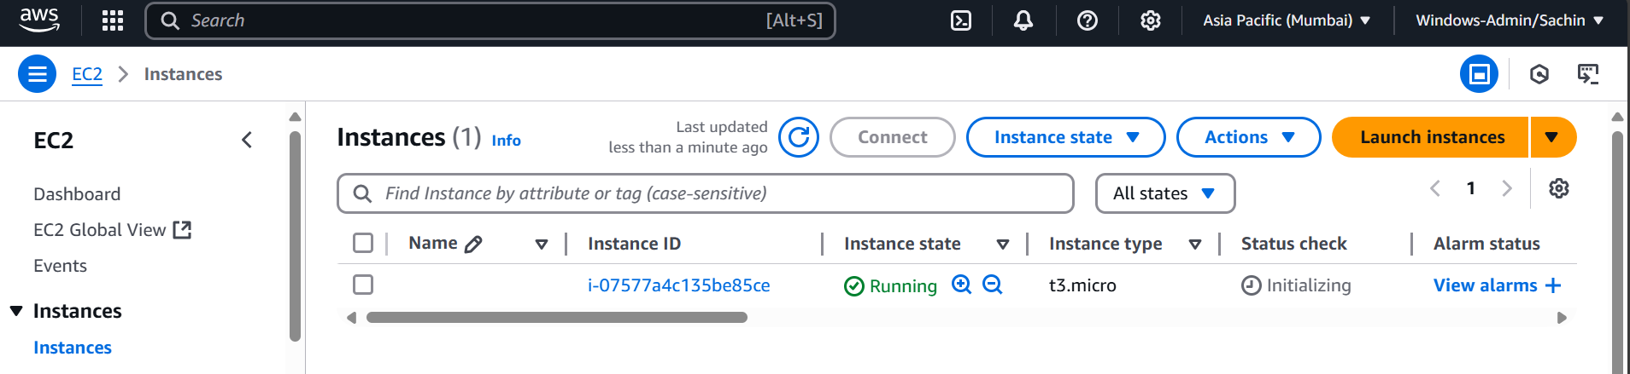
He is able to stop the instance also
